**UNIT-III**

**TELEPHONE**

The word telephone comes from the Greek words tele meaning "from afar," and phone, meaning "sound," "voice," or "voiced sound." The standard definition of a telephone is as follows:

An apparatus for reproducing sound, especially that of the human voice (speech) at a great distance, by means of electricity; consisting of transmitting and receiving instruments connected by a line or wire which conveys the electric current.

The first telephone set that combined a transmitter and receiver into a single hand held unit was introduced in 1878 and called the Butterstamp telephone. You talked into one end and then turned the instrument around and listened with the other end. In 1951, Western Electric Company introduced a telephone set that was the industry standard for nearly at four decades (the rotary dial telephone used by your grandparents). This telephone set is called the Bell System 500-type telephone and is shown in Figure below. In modern-day telephone sets, the rotary dial mechanism is replaced with a Touch-Tone keypad. The modem Touch-Tone telephone is called a 2500-type telephone set and is shown in Figure below.

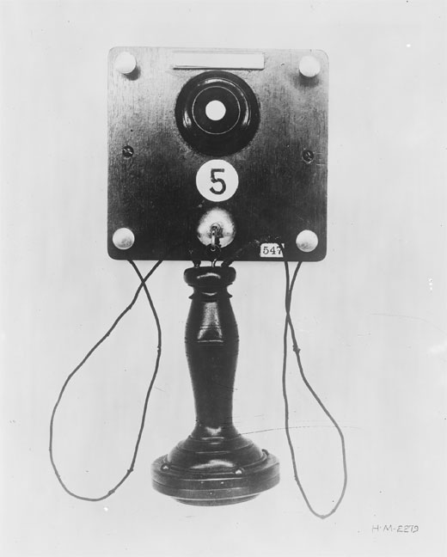

**Fig (a): Butter Stamp Telephone**

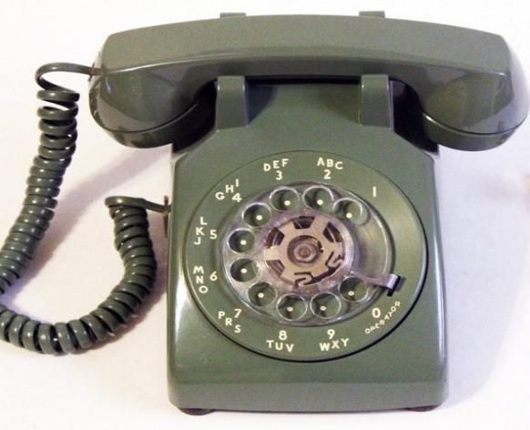

**Fig (b): 500 type Telephone**



**Fig(c) 2500 type Telephone**

The original telephone system was designed for full duplex analog communication of voice signals. Today, the telephone system is still primarily used for voice, but it employs mostly digital techniques, not only in signal transmission but also in control operations.

The telephone system permits any telephone to connect with any other telephone in the world. This means that each telephone must have a unique identification code—the 10-digit telephone number assigned to each telephone. The telephone system provides a means of recognizing each individual number and provides switching systems that can

connect any two telephones.

**TELEPHONE SYSTEM**

The block diagram of basic telephone system is shown below:

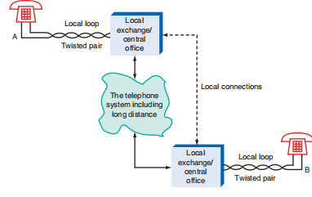

The block diagram of long distance telephone system is shown below:

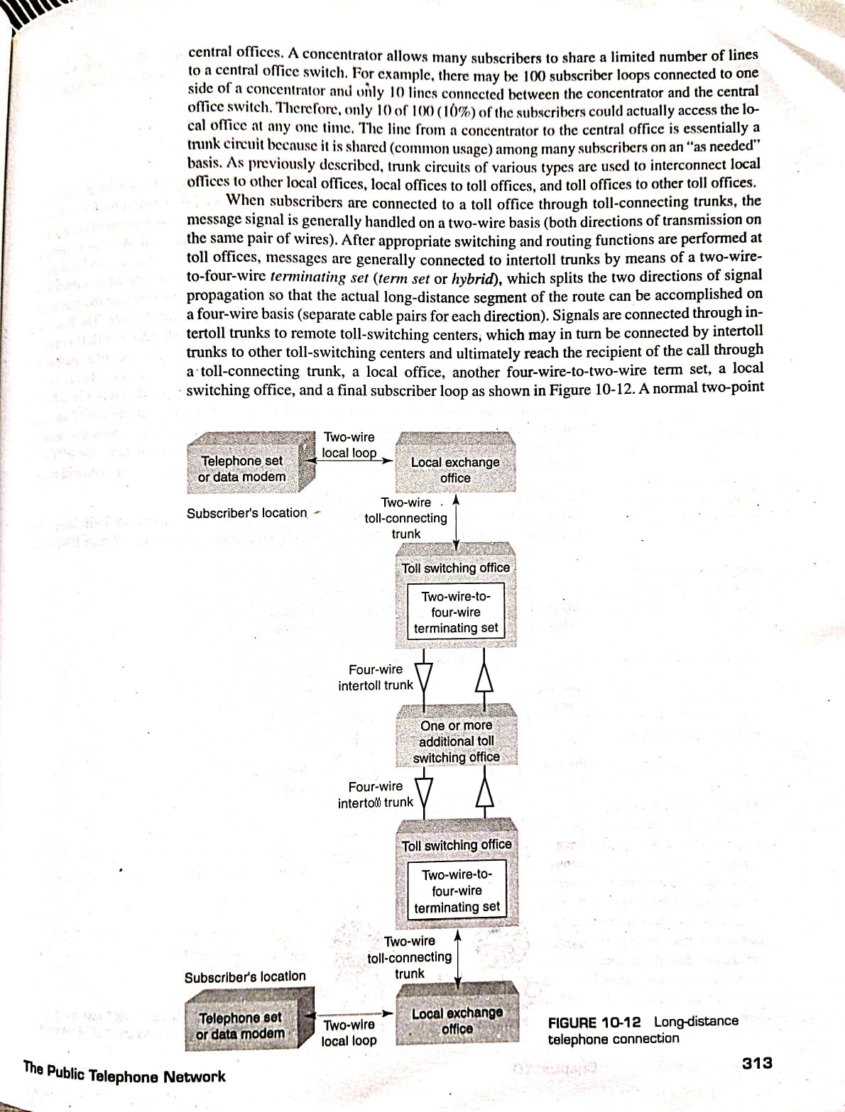

**Local loop:**

The two-wire, twisted-pair connection between the telephone and the central office is referred to as **the local loop or subscriber loop**.It is also referred to as the **last mile or the first mile**. The circuits in the telephone and at the central office form a complete electric circuit, or loop. This single circuit is analog and carries both dc and ac signals. The dc power for operating the telephone is generated at the central office and supplied to each telephone over the local loop. The ac voice signals are transmitted

along with the dc power. Despite the fact that only two wires are involved, full duplex operation, i.e., simultaneous send and receive, is possible. All dialing operations are carried on this single twisted-pair cable.

**Local Exchange/ Central Office:**

Exchanges connected directly to local loops are called local exchanges. Because local exchanges are centrally located within the area they serve, they are often called central offices (CO).Telephone exchanges are strategically placed around a city to minimize the distance between a subscriber's location and the exchange and also to optimize the number of stations(location of the instrument such as telephone set, modem,cordless telephone) connected to any one exchange. The size of the service area covered by an exchange depends on subscriber density and subscriber calling patterns.The purpose of a telephone exchange is to provide a path for a call to be completed between two parties.

To process a call, a switch at the local exchange must provide three primary functions:

1)Identify the subscribers

2)Set up or establish a communications path

3)Supervise the calling processes

Local exchanges can directly interconnect any two subscribers whose local loops are connected to the same local exchange.

Figure (d) shows a local ex- change with six telephones connected to it. Note that all six telephone numbers begin with 87. One subscriber of the local exchange can call another subscriber by simply dialing their seven-digit telephone number. The switching machine performs all tests and switching operations necessary to complete the call. A telephone call completed within a single local ex- change is called an **intra office** call (sometimes called an **intra switch** call). Figure(e) shows how two stations serviced by the same exchange (874-3333 to 874-4444) are inter- connected through a common local switch.

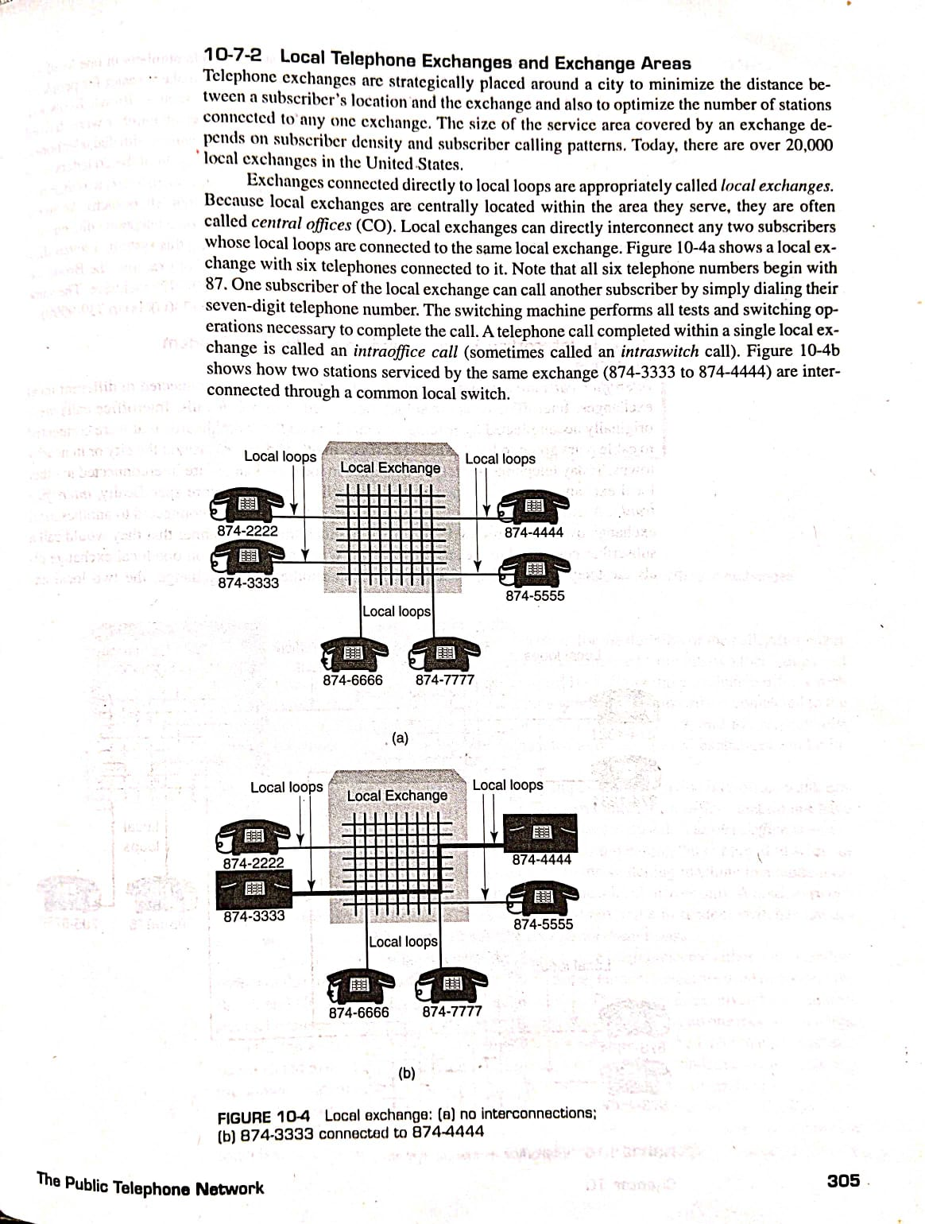

**Fig (d):Local exchange with no interconnections**



**Fig(e)Local exchange connecting 874-3333 to 874-4444**

**Trunk Circuits:**

A trunk circuit is similar to a local loop except trunk circuits are used to interconnect two telephone offices. The primary difference between a local loop and a trunk is that a local loop is permanently associated with a particular station, whereas a trunk is a common- usage connection. A trunk circuit can be as simple as a pair of copper wires twisted together or as sophisticated as an optical fiber cable.Trunk circuits can be two wire or four wire, depending on what type of facility is used.

**Interoffice calls** are calls placed between two stations that are connected to different local exchanges. Interoffice calls are sometimes called inter switch calls.The telephone-switching machines in local exchanges are interconnected to other local exchange offices on special facilities called trunks or, more specifically, interoffice trunks. A subscriber in one local exchange can call a subscriber connected to another local exchange over an interoffice trunk circuit in much the same manner that they would call a subscriber connected to the same exchange. When a subscriber on one local exchange dials the telephone number of a subscriber on another local exchange, the two local exchanges are interconnected with an interoffice trunk for the duration of the call. After either party terminates the call, the interoffice trunk is disconnected from the two local loops and made available for another interoffice call.

Fig(f)shows three exchange offices with two subscribers connected to each.

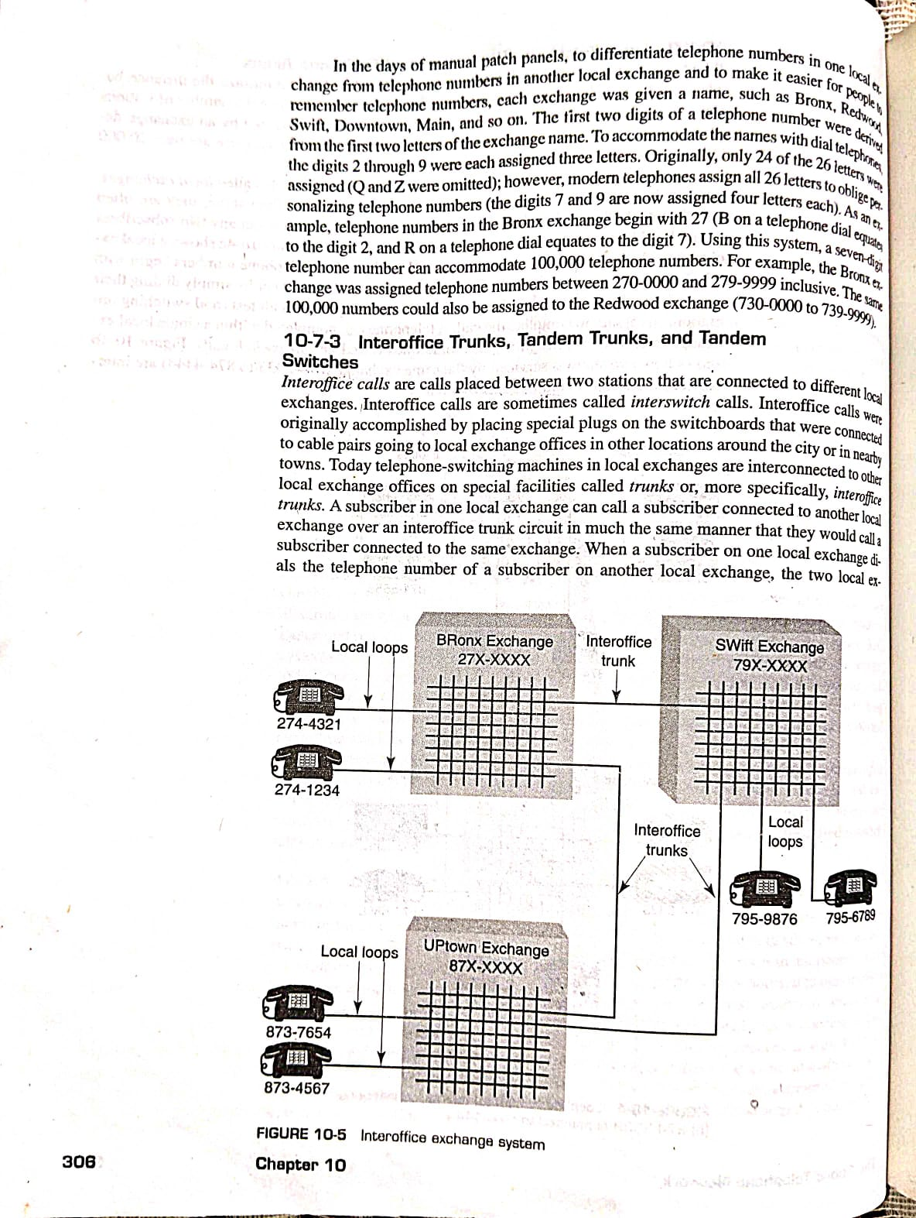

**Fig(f): Interoffice exchange system**

The telephone numbers for subscribers connected to the Bronx, Swift, and Uptown exchanges begin with the digits 27, 79, and 87 respectively.

Fig (g) shows how two subscribers connected to different local exchanges can be interconnected using an interoffice trunk.

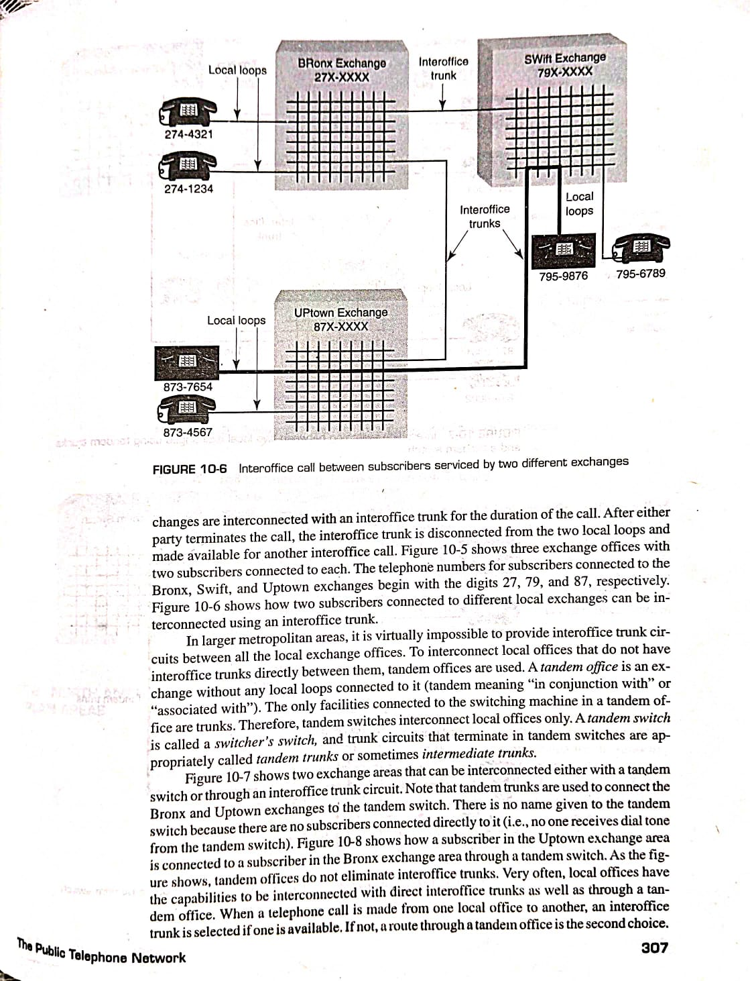

**Fig(g): Interoffice call between subscribers serviced by two different exchanges**

**Tandem Trunks:**

In larger metropolitan areas, it is virtually impossible to provide interoffice trunk circuits between all the local exchange offices. To interconnect local offices that do not have interoffice trunks directly between them, tandem offices are used. A tandem office is an exchange without any local loops connected to it (tandem meaning "in conjunction with" or "associated with"). The only facilities connected to the switching machine in a tandem office are trunks. Therefore, tandem switches interconnect local offices only. A tandem switch is called a switcher's switch, and trunk circuits that terminate in tandem switches are called tandem trunks or sometimes intermediate trunks.

Fig (h) shows two exchange areas that can be interconnected either with a tandem switch or through an interoffice trunk circuit

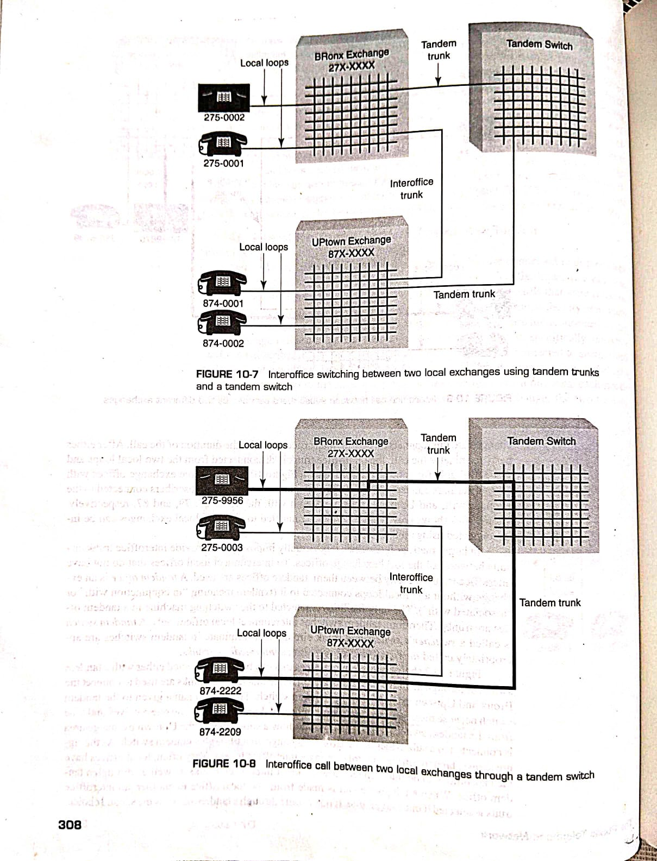

**Fig (h): Inter office switching between two local exchanges using tandem trunks and a tandem switch**

Note that tandem trunks are used to connect the Bronx and Uptown

exchanges to the tandem switch. There is no name given to the tandem

switch because there are no subscribers connected directly to it.

Fig(i) shows how a subscriber in the Uptown exchange area is connected

to a subscriber in the Bronx exchange area through a tandem switch.



**Fig(i)Interoffice call between two local exchanges through a tandem switch**

As the figure shows, tandem offices do not eliminate interoffice trunks.

Very often, local offices have the capabilities to be interconnected with

direct interoffice trunks as well as through a tandem office. When

telephone call is made from one local office to another, an interoffice

trunk is selected if one is available. If not, a route through a tandem office

is the second choice.

**Toll connecting Trunks,Inter toll Trunks and Toll offices:**

Interstate long-distance telephone calls require a special telephone office

called a toll office.When a subscriber initiates a long-distance call, the

local exchange connects the caller to a toll office through a facility called

a toll-connecting trunk (sometimes called an interoffice toll trunk). Toll

offices are connected to other toll offices with inter toll trunks.

Fig(j)shows how local exchanges are connected to toll offices and

how toll offices are connected to other toll offices.

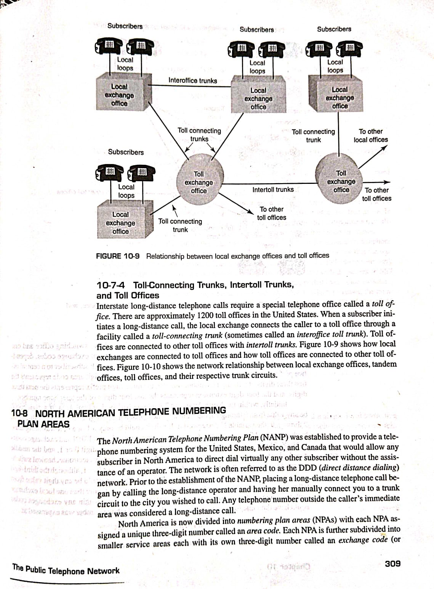

**Fig (j)Relationship between local exchange offices and toll offices**

Figure (k) shows the network relationship between local exchange

offices, tandem offices,toll offices, and their respective trunk circuits.

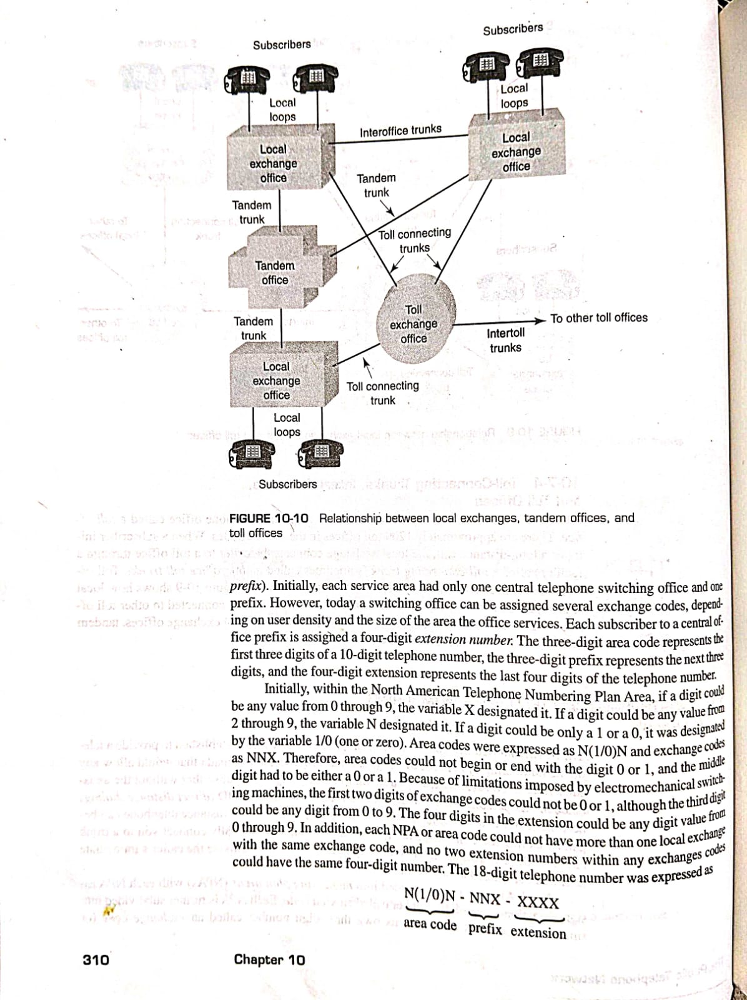

**Fig(k):Relationship between local exchange office,tandem offices and toll offices**

Anyone who uses a telephone on a telephone circuit is a part of global communication network called the **Public Telephone Network(PTN)**

Subscribers of the PTN share equipment and facilities that are available to all the public subscribers of the network..This equipment is called common usage equipment which includes transmission facilities and telephone switches.Since the subscribers to the public network are interconnected only temporarily through switches, the network is often called the **Public Switched Telephone Network(PSTN).**

**TELEPHONE SET:**

The basic block diagram of a telephone set is shown in figure(l) below:

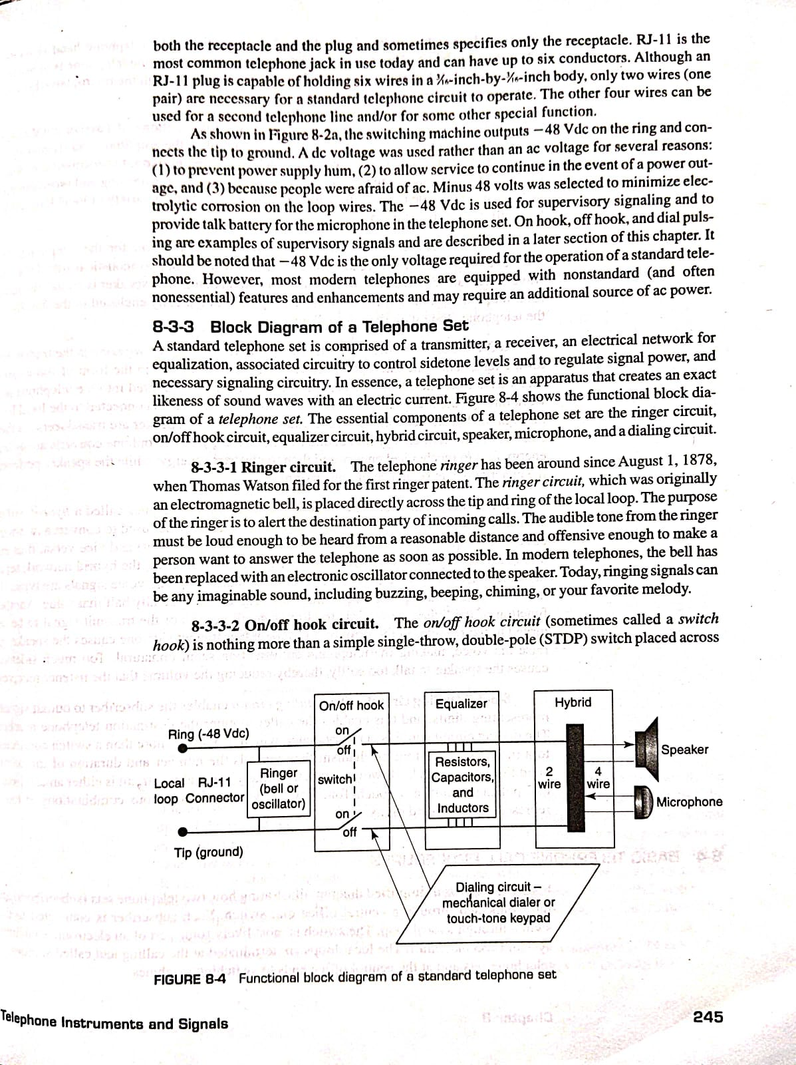

**Fig(l):Basic Telephone Set**

The essential components of a telephone set are the ringer circuit, on/off hook circuit, equalizer circuit, hybrid circuit, speaker, microphone, and a dialing circuit.

Ringer Circuit:

The ringer circuit, which was originally an electromagnetic bell, is placed directly across the tip and ring of the local loop. The purpose of the ringer is to alert the destination party of incoming calls. The audible tone from the ringer must be loud enough to be heard from a reasonable distance and offensive enough to make a person want to answer the telephone as soon as possible. In modern telephones, the bell has been replaced with an electronic oscillator connected to the speaker.

On/Off Hook circuit:

The on/off hook circuit is a simple single-pole, double-throw (SPDT) switch placed across the the tip and ring. The switch is mechanically connected to the telephone handset so that when the telephone is idle (on hook), the switch is open. When the telephone is in use (off hook), the switch is closed, completing an electrical path through the microphone between the tip and ring of the local loop.

Equalizer Circuit:

Equalizers are combinations of passive components (resistors, capacitors, and so on) that are used to regulate the amplitude and frequency response of the voice signals.

Hybrid Circuit:

The hybrid network (sometimes called a hybrid coil or duplex coil) in a telephone set is a special balanced transformer used to convert a two-wire circuit (the local loop) into a four-wire circuit (the telephone set) and vice versa, thus enabling full-duplex operation over a two-wire circuit. In essence, the hybrid network separates the transmitted signals from the received signals. Outgoing voice signals are typically 1-V to 2-V range, while incoming voice signals are typically half that value. Another function of the hybrid network is to allow a small portion of the transmit signal to be returned to the receiver.This feedback signal is called a **sidetone.** Insufficient sidetone causes the speaker to raise his voice, making the telephone conversation seem unnatural. Too much sidetone causes the speaker to talk too softly, thereby reducing the volume that the listener receives.

Microphone:

The microphone is connected to the local loop through the hybrid network. For all practical purposes, the microphone is the transmitter for the telephone. The microphone converts acoustical signals in the form of sound pressure waves from the caller to electrical signals that are transmitted into the telephone network through the local subscriber loop.

Speaker:

The speaker is the receiver for the telephone. The speaker converts electrical signals received from the local loop to acoustical signals (sound waves) that can be heard and understood by a human being. The speaker is connected to the local loop through the hybrid network.The speaker is typically enclosed in the handset of the telephone along with the microphone.

Dialing Circuits:

The dialing circuit enables the subscriber to output signals representing digits, and this enables the caller to enter the destination telephone number. The dialing circuit could be a rotary dialer, or a Touch-Tone keypad, which sends various combinations of tones representing the called digits

Most modern telephones use a dialing system known as Touch

Tone. It uses pairs of audio tones to create signals representing the numbers to be dialed. This dialing system is referred to as the dual-tone multi frequency (DTMF) system.

A typical DTMF keyboard on a telephone is shown in Fig(m) below

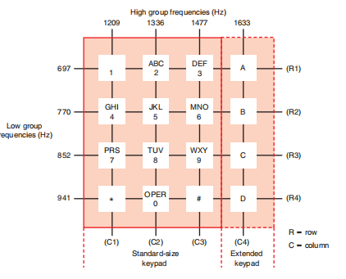

**Fig(m): DTMF Keypad**

Most telephones use a standard keypad with 12 buttons or switches for the numbers 0 through 9 and the special symbols * and #. The DTMF system also accommodates four additional keys for special applications.

In Fig. 18-5 numbers represent audio frequencies associated with each row and column of push buttons. For example, the upper horizontal row containing the keys for 1, 2, and 3 is labeled 697, which means that when any one of these three keys is depressed, a sine wave of 697 Hz is produced. Each of the four horizontal rows produces a different frequency. The horizontal rows generate what is generally known as the low group of frequencies. A higher group of frequencies is associated with the vertical columns of keys. For example, the keys for the numbers 2, 5, 8, and 0 produce a frequency of 1336 Hz when depressed.

If the number 2 is depressed, two sine waves are generated simultaneously, one at 697 Hz and the other at 1336 Hz. These two tones are linearly mixed. This combination produces a unique sound and is easily detected and recognized at the central office as

the signal representing the dialed digit 2.

**Functions of Telephone set:**

The basic functions of a telephone set are as follows:

1. Notify the subscriber when there is an incoming call with an audible signal, such as a bell, or with a visible signal, such as a flashing light. This signal is analogous to an interrupt signal on a microprocessor, as its intent is to interrupt what you are doing. These signals are purposely made annoying enough to make people want to answer the telephone as soon as possible.

2. Provide a signal to the telephone network verifying when the incoming call has been acknowledged and answered (i.e., the receiver is lifted off hook).

3. Convert speech (acoustical) energy to electrical energy in the transmitter and vice versa in the receiver. Actually, the microphone converts the acoustical energy to mechanical energy, which is then converted to electrical energy. The speaker performs the opposite conversions.

4. Incorporate some method of inputting and sending destination telephone numbers (either mechanically or electrically) from the telephone set to the central office switch over the local loop. This is accomplished using either rotary dialer(pulses) or Touch-Tone pads (frequency tones).

5. Regulate the amplitude of the speech signal the calling person outputs onto the telephone line. This prevents speakers from producing signals high enough in amplitude to interfere with other people's conversations taking place on nearby cable pairs (crosstalk).

6. Incorporate some means of notifying the telephone office when a subscriber wishes to place an outgoing call (i.e., handset lifted off hook). Subscribers cannot dial out until they receive a dial tone from the switching machine.

7. Ensure that a small amount of the transmit signal is fed back to the speaker, enabling talkers to hear themselves speaking. This feedback signal is called sidetone or talkback. Sidetone helps prevent the speaker from talking too loudly.

8. Provide an open circuit (idle condition) to the local loop when the telephone is not in use (i.c., on hook) and a closed circuit (busy condition) to the local loop when the telephone is in use (off hook).

9. Provide a means of transmitting and receiving call progress signals between the central office switch and the subscriber, such as on and off hook, busy, ringing, dial pulses, Touch-Tone signals and dial tone.

**BASIC TELEPHONE CALL PROCEDURES:**

Figure(n) shows a simplified diagram illustrating how two telephone sets (subscribers) are switch through a local loop. The switch is most likely some sort of an electronic switching interconnected through a central office dial switch. Each subscriber is connected to the system (ESS machine). The local loops are terminated at the calling and called stations in telephone sets and at the central office ends to switching machines.

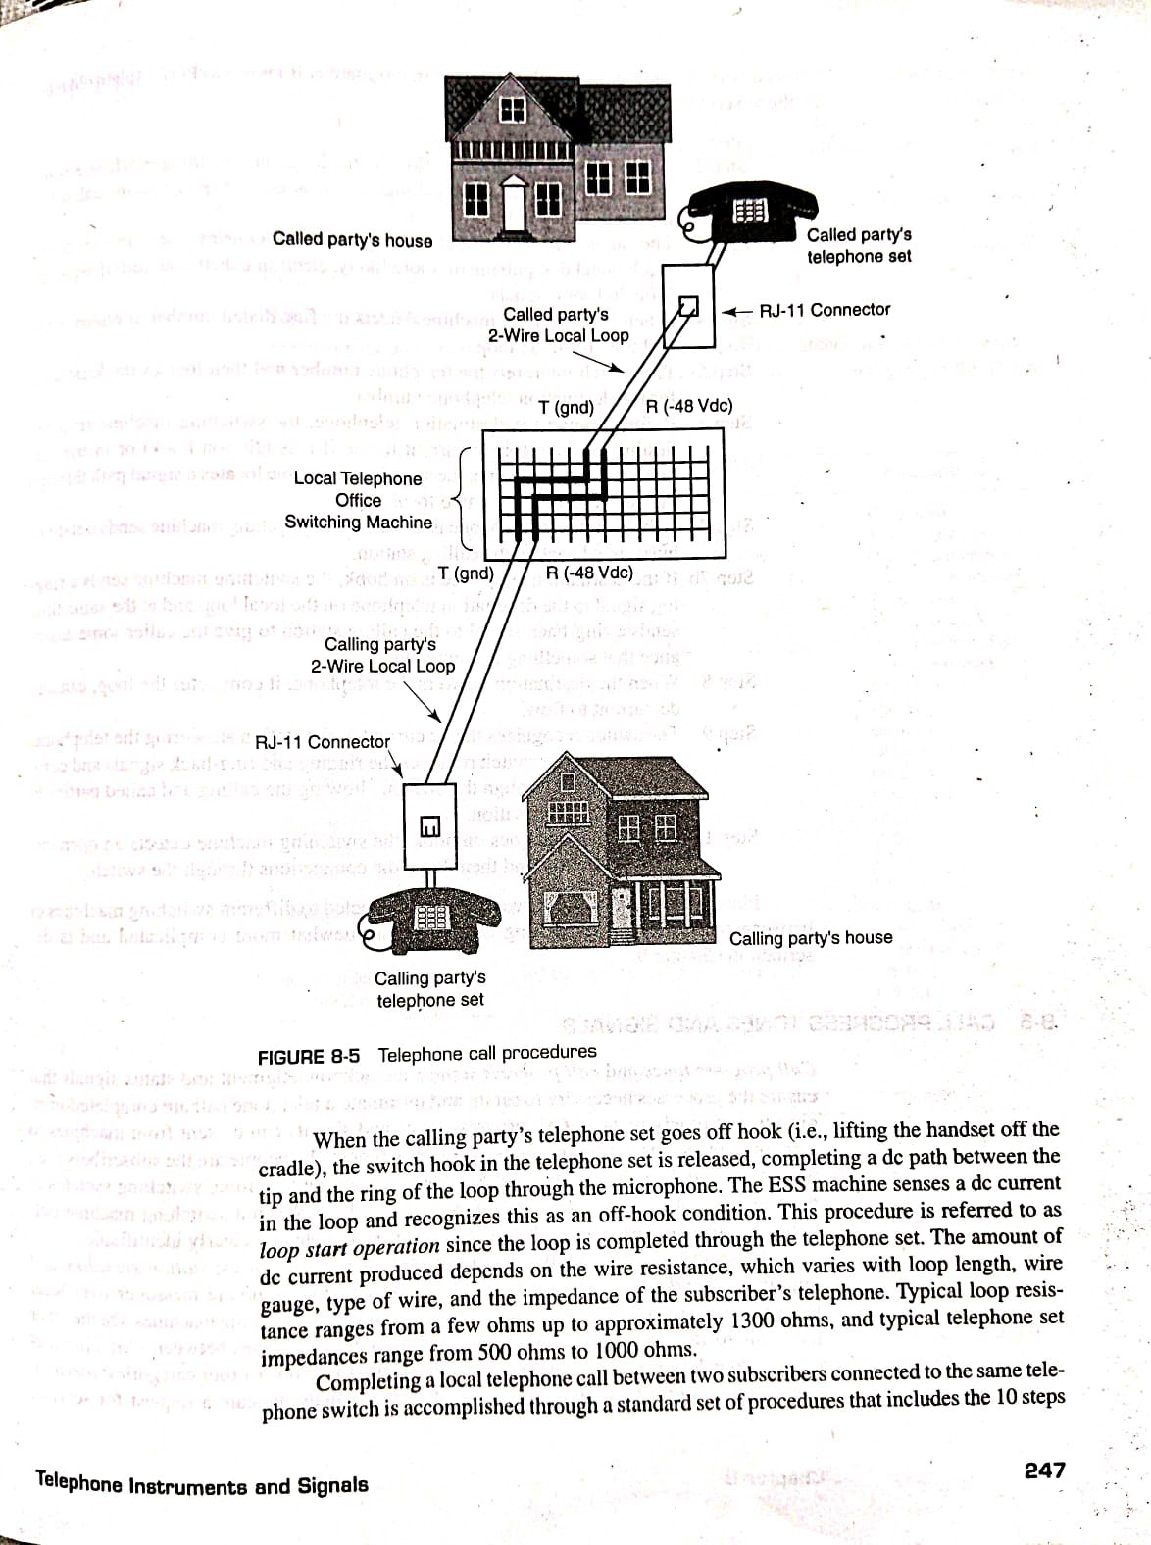

**Fig(n): Telephone Call Procedure**

When the calling party's telephone set goes off hook (i.e., lifting the handset off the cradle), the switch hook in the telephone set is released, completing a dc path between the tip and the ring of the loop through the microphone. The ESS machine senses a dc current in the loop and recognizes this as an off-hook condition. This procedure is referred to as loop start operation since the loop is completed through the telephone set.

Completing a local telephone call between two subscribers connected to the same telephone switch is accomplished through a standard set of procedures that includes the following 10 steps:

Accessing the telephone system in this manner is known as **POTS (plain old telephone service)**

Step 1: Calling station goes off hook.

Step 2: After detecting a dc current flow on the loop, the switching machine returns an audible dial tone to the calling station, acknowledging that the caller has access to the switching machine.

Step 3: The caller dials the destination telephone number using one of two methods: mechanical dial pulsing or, more likely, electronic dual-tone multi frequency (Touch-Tone) signals.

Step 4: When the switching machine detects the first dialed number, it removes the dial tone from the loop.

Step 5 :The switch interprets the telephone number and then locates the local loop for the destination telephone number.

Step 6: Before ringing the destination telephone, the switching machine tests the destination loop for dc current to see if it is idle (on hook) or in use (off hook). At the same time, the switching machine locates a signal path through the switch between the two local loops.

Step 7a: If the destination telephone is off hook, the switching machine sends a station busy signal back to the calling station.

Step 7b: If the destination telephone is on hook, the switching machine sends a ringing signal to the destination telephone on the local loop and at the same time sends a ring-back signal to the calling station to give the caller some assurance that something is happening.

Step 8: When the destination answers the telephone, it completes the loop, causing dc current to flow.

Step 9: The switch recognizes the dc current as the station answering the telephone. At this time, the switch removes the ringing and ring-back signals and completes the path through the switch, allowing the calling and called parties to begin their conversation.

Step 10: When either end goes on hook, the switching machine detects an open circuit on that loop and then drops the connections through the switch.

**LONG DISTANCE CALL ESTABLISHMENT IN ANALOG TELEPHONE SYSTEM**

The block diagram of long distance telephone system is shown below:



In the old days, a long-distance call was a manual process that relied on a hierarchical system of telephone exchanges and human operators. Toll offices were the key hubs in this network, connecting different local areas and making long-distance communication possible.

The procedure followed in the establishment of a long distance call is discussed below:

1.The process began at the local telephone exchange. Every house in a particular town or neighborhood was connected to the central office via its own pair of copper wires. When we lift the receiver, a light would appear on the switchboard, and the local operator would connect to our line and asks with whom we want to talk to

### 2.If we want to make a long distance call which is outside of the local exchange, we would tell the operator that we want to make a toll call. The local operator would then connect our line to a special trunk line that led to a toll office.

3.The toll office was the nerve center for long-distance calls. At this office, a specialized toll operator would take our request. We would provide the city and the number we want to reach. The toll operator's job was to coordinate the connection with the destination city.

1. The toll operator of our city would then establish a connection to another toll office in the destination city. This often involve a complex chain of manual connections. The call might be routed through several intermediate toll offices, especially for calls across the country. Each operator in this chain would manually connect the call to the next toll office on the route.

5.Once the call reached the toll office in the destination city, the final operator would take over. This operator would then connect the call to the local exchange that served the recipient's phone number. From there, the local operator at the final exchange would ring the recipient's phone.

**Subcriber Interface:**

Most telephones are connected to a local central office by way of the two-line, twisted pair local loop cable. The central office contains all the equipment that operates the telephone and connects it to the telephone system that makes the connection to any other telephone. The central office is provided with basic circuits that power the telephone and provide all the basic functions, such as ringing, dial tone, and dialing supervision. These circuits are collectively referred to as the subscriber interface or the **subscriber line interface circuit (SLIC)**. In older central office systems, the subscriber interface circuits used discrete components. Today, most functions of the subscriber line interface are implemented by one or perhaps two integrated circuits plus supporting equipment. The subscriber line interface is also referred to as the line side interface.

The SLIC provides seven basic functions generally referred to as **BORSCHT** (representing the first letters of the functions battery, overvoltage protection, ringing, supervision, coding, hybrid, and test).

A general block diagram of the subscriber interface and BORSCHT functions is given in Fig(o) below:

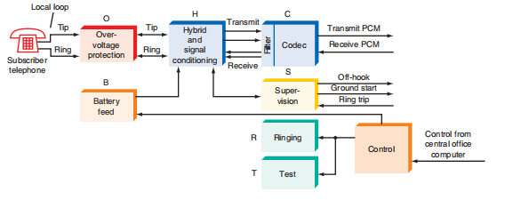

**Fig(o):BORSCHT functions in the subscriber line interface at the central office.**

**Battery:** The subscriber line interface at the central office must provide a dc voltage to the subscriber to operate the telephone. In the United States, this is typically -48 V dc with respect to ground. The actual voltage can be anything between approximately -20 and -80 V when the phone is on the hook, i.e., disconnected. The voltage at the telephone drops to approximately 6 V when the phone is taken off the hook. The large difference between the on-hook and off-hook voltages is due to large voltage drop that occurs across the components in the telephone and the long local loop cable.

**Overvoltage Protection**: The circuits and components that protect the subscriber line interface circuits from electrical damage are referred to collectively as over voltage protection. The phone lines are vulnerable to many types of electrical problems. Lightning is by far the worst threat, although other hazards exist, including accidental connection to an electric power line or some type of mis connection that would occur

during installation. Induced disturbances from other sources of noise can also cause problems.

Over voltage protection ensures reliable telephone operation even under such conditions.

**Ringing:** When a specific telephone is receiving a call, the telephone local office must provide a ringing signal.This is commonly a 90-Vrms ac signal at approximately 20 Hz. The SLIC must connect the ringing signal to the local loop when a call is received. This is usually done by closing relay contacts that connect the ringing signal to the line. The SLIC also detects when the phone is picked up (off hook) so that the ringing signal can be disconnected.

**Supervision:** Supervision refers to a group of functions within the subscriber line interface that monitor local loop conditions and provide various services. For example, the supervision circuits in the SLIC detect when a telephone is picked up to initiate a new call. A sensing circuit recognizes the off-hook condition and signals circuits within

the SLIC to connect a dial tone. The caller then dials the desired number, which causes interconnection through the telephone system.

The supervision circuits continuously monitor the line during the telephone call. The circuits sense when the call is terminated and provide the connection of a busy signal if the called number is not available.

**Coding**: Coding is another name for A/D conversion and D/A conversion. Today, many telephone transmissions are made by way of serial digital data methods. The SLIC may contain codec that converts the analog voice signals to serial PCM format or converts received digital calls back to analog signals to be placed on the local loop. Transmission

over trunk lines to other central offices or toll offices or for use in long-distance transmission is typically by digital PCM signals in modern systems.

**Hybrid**: A hybrid is also used at the central office. It effectively translates the two-wire line of the subscriber back into four lines, two each for the transmitted and received signals. The hybrid provides separate transmit and receive signals. Although a single pair of lines

is used in the local loop to the subscriber, all other connections to the telephone system treat the transmitted and received signals separately and have independent circuits for dealing with them along the way.

**Test Signals**: To check the status and quality of subscriber lines, the phone company often puts special test tones on the local loop and receives resulting tones in return. These can give information about the overall performance of the local loop. The SLIC provides a way to connect the test signals to the local loop and to receive the resulting signals for measurement.

**Electronic Telephones:**

The development of the microprocessor has also affected telephone design. A built-in microprocessor permits automatic control of the

telephone’s functions and provides features such as telephone number storage and automatic dialing and redialing that are not possible in conventional telephones.

The major components of a typical electronic

telephone circuit are shown in Fig.(p) below. Most of the functions are implemented with circuits contained within a single IC.

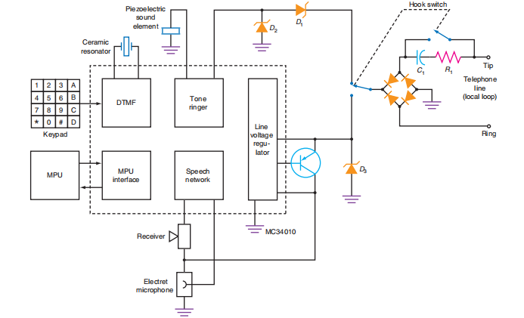**Fig(p):Single-chip electronic telephone.**

The Touch Tone keypad drives a DTMF tone generator circuit.

An external crystal or ceramic resonator provides an accurate frequency reference for generating the dual dialing tones.The tone ringer is driven by the 20-Hz ringing signal from the phone line and drives

a piezoelectric sound element.The IC also contains a built-in line voltage regulator. It takes the dc voltage from the local loop and stabilizes it to provide a constant voltage to the internal electronic circuits. An external zener diode and transistor provide bias to the electret microphone.

The internal speech network contains a number of amplifiers and related circuits that functions like a hybrid in a standard telephone. This IC also contains a microcomputer interface. The box labeled MPU is a single-chip microprocessing unit. Although it is not necessary to use a microprocessor, if automatic dialing and other functions are implemented, this circuit is capable of accommodating them.

The twisted pair from the local loop is connected to the tip and ring. Both the -48V dc and 20-Hz ring voltages will be applied to this bridge rectifier. For direct current, the bridge rectifier provides

polarity protection for the circuit, ensuring that the bridge output voltage is always positive. When the ac ringing voltage is applied, the bridge rectifier rectifies it into a pulsating dc voltage. The hook switch is shown with the telephone on the hook or in the “hung-up” position. Thus the dc voltage is not connected to the circuit at this time.

However, the ac ringing voltage will be coupled through the resistor and capacitor to the bridge, where it will be rectified and applied to the two zener diodes D1 and D2 that drive the tone ringer circuit.

When the telephone is taken off the hook, the hook switch closes, providing a dc path around the resistor and capacitor R1 and C1. The path to the tone ringer is broken, and the output of the bridge rectifier is connected to zener diode D3 and the line voltage regulator.

Thus the circuits inside the IC are powered up and calls may be received or made.

**PAGING SYSTEMS**

Paging systems are simplex wireless communications systems designed to alert subscribers of awaiting messages. Paging transmitters relay radio signals and messages from wire-line and cellular telephones to subscribers carrying portable receivers.A pager also known as a beeper is a device that is essentially a small battery operated radio receiver that when the proper signal is received will set off an alert (either audible or vibrating) and display either a numeric message such as a phone number or a word message if the pager is alphanumeric capable.

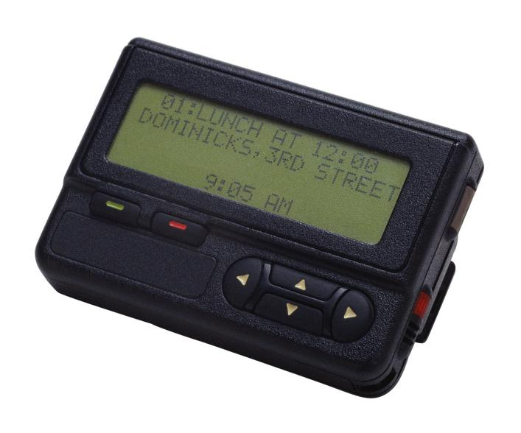

**Fig(q):Pager**

The simplified block diagram of a paging system is shown in Figure (r)

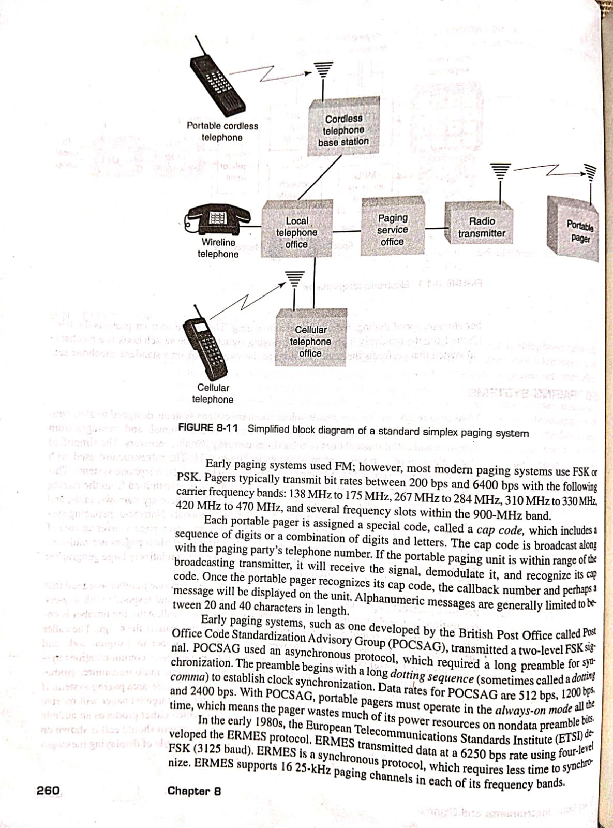

**Fig(r) Paging system**

Standard paging systems are one way, with signals transmitted from the paging system to portable pager and never in the reverse direction. There are narrow, mid and wide-area pagers (sometimes called local, regional, and national). Narrow area paging systems operate only within a building or building complex, mid area pagers cover an area of several square miles and wide area pagers operate worldwide. Most pagers are mid area where one centrally located high-power transmitter can cover a relatively large geographic area, typically between 6 and 10 miles in diameter.

To contact a person carrying a pager, simply dial the telephone number assigned that person's portable pager. The paging company receives the call and responds with a query requesting the telephone number you wish the paged person to call. After the number is entered, a terminating signal is appended to the number, which is usually the # sign. The caller then hangs up. The paging system converts the telephone number to a digital code and transmits it in the form of a digitally encoded signal over a wireless communications system. The signal may be simultaneously sent from more than one radio transmitter (sometimes called simulcasting or broadcasting), as is necessary in a wide-area paging system. If the paged person is within range of a broadcast transmitter, the targeted pager will receive the message. The message includes a notification signal, which either produces an audible beep or causes the pager to vibrate, and the number the paged unit should call is shown on an alphanumeric display. Some newer paging units are also capable of displaying messages as well as the telephone number of the paging party.

Early paging systems used FM but most modern paging systems use FSK or PSK. Pagers typically transmit bit rates between 200 bps and 6400 bps with the following carrier frequency bands: 138 MHz to 175 MHz, 267 MHz to 284 MHz, 310 MHz to 330 MHz, 420 MHz to 470 MHz.Each portable pager is assigned a special code, called a cap code, which includes a sequence of digits or a combination of digits and letters. The cap code is broadcast along with the paging party's telephone number. If the portable paging unit is within range of broadcasting transmitter, it will receive the signal, demodulate it, and recognize its cap code. Once the portable pager recognizes its cap code, the callback number and perhaps 'message will be displayed on the unit. Alphanumeric messages are generally limited to between 20 and 40 characters in length.

Early paging systems, such as one developed by the British Post Office called Post Office Code Standardization Advisory Group (POCSAG), transmitted a two-level FSK signal. POCSAG used an asynchronous protocol, which required a long preamble to establish clock synchronization. Data rates for POCSAG are 512 bps, 1200 bps and 2400bps.With POCSAG, portable pagers must operate in the always-on mode which means the pager wastes much of its power resources on nondata preamble bits.

In the early 1980s, the European Telecommunications Standards Institute (ETSI) developed ERMES protocol(European Radio Messaging System).ERMES transmitted data at a 6250 bps rate using four-level FSK.It is a synchronous protocol, which requires less time to synchronize. ERMES supports 16 25-kHz paging channels in each of its frequency bands.

The most recent paging protocol, FLEX(Flexible Wide Area Paging Protocol) was developed in the 1990s. FLEX is designed to minimize power consumption in the portable pager With FLEX, each cycle is comprised of 128 data frames, which are transmitted only once during a 4-minute period. Each frame lasts for 1.875 seconds and includes two synchronizing sequences, a header containing frame information and pager identification addresses, and 11 discrete data blocks. Each portable pager is assigned a specific frame (called a home frame) within the frame cycle that it checks for transmitted messages. Thus, a pager operates in the high-power standby condition for only a few seconds every 4 minutes (this is called the wakeup time). The rest of the time, the pager is in an ultra-low power standby condition. When a pager is in the wakeup mode, it synchronizes to the frame header and then adjusts itself to the bit rate of the received signal. When the pager determines that there is no message waiting, it puts itself back to sleep, leaving only the timer circuit active.

**INTERNET TELEPHONY**

Internet telephony, also called Internet Protocol (IP) telephony or Voice over Internet Protocol (VoIP), uses the Internet to carry digital voice telephone calls.It uses the Internet’s vast fiber-optic cabling network to carry phone calls without phone company charges. This new telephony system is slowly replacing conventional phones, especially in large companies. It offers the benefits of lower long distance calling charges and reduces the amount of new equipment needed,because phone service is essentially provided over the same local-area network (LAN) that interconnects the PCs in an organization.

There are two basic parts to an IP phone call: the “dialing” process, which establishes an initial connection, and the voice signal flow.

**Voice Signal Flow:** Fig.(s) shows the signal flow and major operations that take place during an IP phone call. The voice signal is first amplified and digitized by an analog-to-digital converter (ADC) that is part of a coder-decoder (codec) circuit, which also includes a digital-to-analog converter (DAC). The ADC usually samples the voice signal at 8 kHz and produces an 8-bit word for each sample. These samples occur one after another serially and therefore produce a 64-kbps digital signal. A

relatively wide bandwidth is needed to transmit this bit stream (64 kHz or more). To reduce the data rate and the need for bandwidth, the bit stream is processed by a voice encoder that compresses the voice signal. This compression is usually done by DSP processor chip.The output is at a greatly reduced serial digital data rate.The type of compression used is determined by International Telecommunications Union standards.

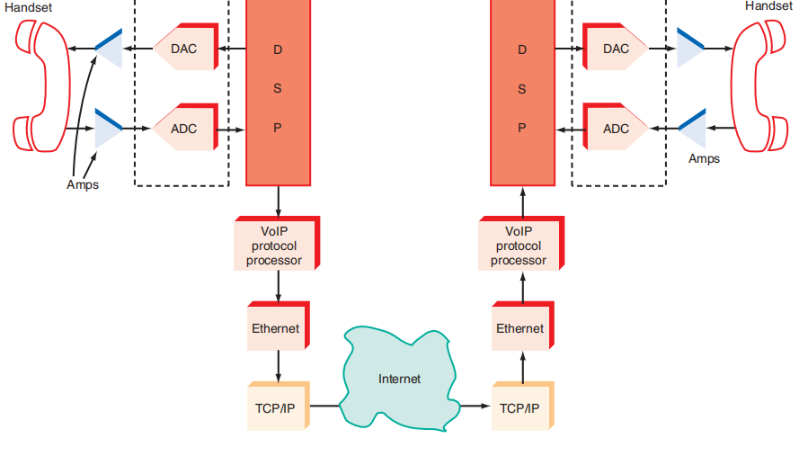

The 64-kbps digital signal is designated as standard G.711 and is better known as pulse-code modulation (PCM). Standard G.729a is probably

the most common compression standard used and results in an 8-kbps digital voice signal. Another popular standard is G.723, which produces an even more highly compressed 5.3-kbps signal at the expense of some voice quality. Numerous other compression standards are used and they are selected based upon the application. Most VoIP phones contain all the common compression standard algorithms in the DSP memory for use as

called for. The signal is also processed in the DSP to provide echo cancellation, a problem in digital telephony.

The resulting serial digital signal is put into a special packet by a microcomputer processor running a VoIP protocol and then transmitted by Ethernet over a LAN or via a high-speed Internet connection such as is available from a cable TV company or on DSL. From there the signal travels over standard available Internet connections using

TCP/IP through multiple servers and routers until it comes to the desired location. At the receiving phone, the process is reversed. The Internet signal gets converted back to Ethernet, and then the VoIP processor recovers the original packet. From there, the compressed data is extracted, decompressed by a DSP and sent to the DAC in the codec where the original voice is heard.

One of the main problems with VoIP is that it takes a relatively long time to transmit the voice data over the Internet. The packets may take different routes through the Internet. They all do eventually arrive at their intended destination, but often the packets are out of sequence. The receiving phone must put them back together in the correct sequence.

In the PSTN, the dialing process initiates multiple levels of switching that literally connects the calling phone to the called phone. That link is maintained for the duration of the call because the switches stay in place and the electronic paths stay dedicated to the call. In Internet telephony, no such temporary dedicated link is established because of the packetized nature of the system. This is taken care of by a special protocol developed for this purpose. The initial protocol used was the ITU H.323. Today, however, a newer protocol established by the Internet Engineering Task Force (IETF) called the session initiation protocol (SIP) has been adopted as the de facto standard. In both cases, the protocol sets up the call and then makes sure that the voice packets produced by the calling phone get sent to the receiving phone in a timely manner.